To See Hidden Folders, Archives in Mac

Press the Keys Upper Case + cmd + . (dot)

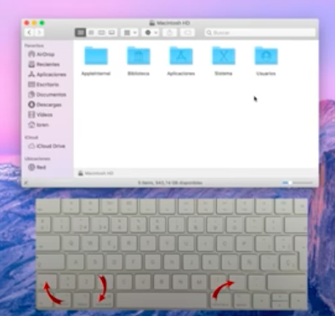

git config-global user.name “UsuariodeGitHub”

git config-global user.email “emaildeGitHub”